DIFFERENT TYPES OF ACTIVATION FUNCTIONS
IN NEURAL NETWORKS

Name: Sowmiya J
Department: Biotechnology
Register No: 124011101575
Course name: Neural Network
Course code: U24BT605

1. Introduction
An activation function is a mathematical function used in an artificial neural network to determine the output of a neuron. It introduces non-linearity into the network, allowing the neural network to learn complex relationships between input variables.
Without an activation function, even a deep neural network would behave essentially like a linear model and would have limited ability to solve complex problems.
z = w₁x₁ + w₂x₂ + ... + wₙxₙ + b
where x₁, x₂, ... xₙ are input values, w₁, w₂, ... wₙ are weights, b is the bias, and z is the weighted input.
The activation function is then applied to z: a = f(z), where f represents the activation function.
2. Major Types of Activation Functions
Binary Step Function
Linear Function
Sigmoid Function
Hyperbolic Tangent (Tanh)
Rectified Linear Unit (ReLU)
Leaky ReLU
Exponential Linear Unit (ELU)
Softmax Function
3. Binary Step Function
The Binary Step function produces one of two possible outputs. It is mainly used when a neuron needs to make a simple binary decision.
Formula: f(x) = 0, if x < 0; 1, if x ≥ 0
Range: {0, 1}

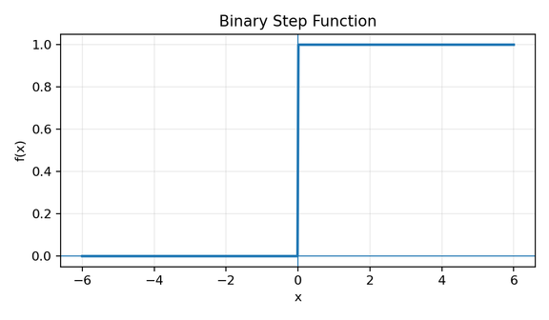

Figure: 3. Binary Step Function graph
Advantages:
Very simple to understand and implement.
Computationally inexpensive.
Suitable for simple binary decisions.
Applications:
Simple binary classification
Perceptrons
Basic decision-making models
4. Linear Activation Function
The linear activation function produces an output directly proportional to its input.
Formula: f(x) = x (or more generally, f(x) = ax + b)
Range: (-∞, +∞)

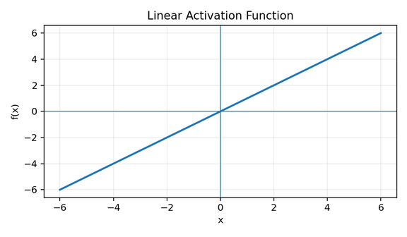

Figure: 4. Linear Activation Function graph
Advantages:
Very simple.
Easy to compute.
Useful when the output needs to have a continuous value.
Applications:
Regression
Predicting temperature
Predicting concentration
Predicting biological measurements
5. Sigmoid Activation Function
The sigmoid function is an S-shaped activation function that converts any real-valued input into a value between 0 and 1.
Formula: f(x) = 1 / (1 + e⁻ˣ)
Range: (0, 1)

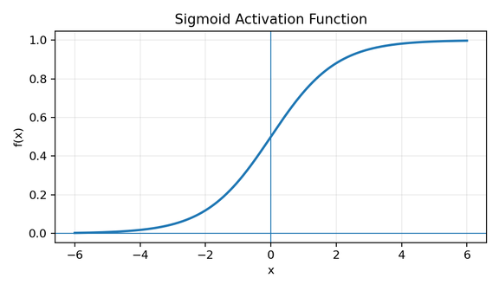

Figure: 5. Sigmoid Activation Function graph
Advantages:
Output is bounded between 0 and 1.
Easy to interpret as a probability.
Smooth and differentiable.
Useful for binary classification.
Applications:
Binary classification
Probability prediction
Biological classification
6. Hyperbolic Tangent (Tanh)
The Tanh function is an S-shaped activation function whose output is centered around zero.
Formula: f(x) = tanh(x) = (eˣ − e⁻ˣ) / (eˣ + e⁻ˣ)
Range: (-1, 1)

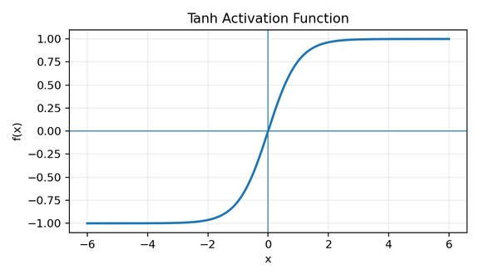

Figure: 6. Hyperbolic Tangent (Tanh) graph
Advantages:
Zero-centered output.
Smooth and differentiable.
Useful in some recurrent neural networks.
Applications:
Hidden layers
Recurrent neural networks
Sequence modelling
Classification
7. ReLU (Rectified Linear Unit)
ReLU is one of the most widely used activation functions in modern deep neural networks.
Formula: f(x) = max(0, x) = 0 if x < 0; x if x ≥ 0
Range: [0, +∞)

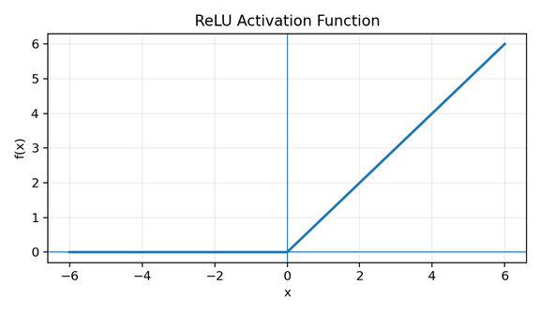

Figure: 7. ReLU (Rectified Linear Unit) graph
Advantages:
Simple and computationally efficient.
Helps reduce the vanishing gradient problem compared with sigmoid and tanh.
Produces sparse activations.
Works well in deep neural networks.
Applications:
Deep neural networks
CNNs
Image classification
Biological image analysis
Genomic data analysis
8. Leaky ReLU
Leaky ReLU is a modified version of ReLU designed to reduce the dying ReLU problem.
Formula: f(x) = αx if x < 0; x if x ≥ 0, commonly α = 0.01
Range: (-∞, +∞)

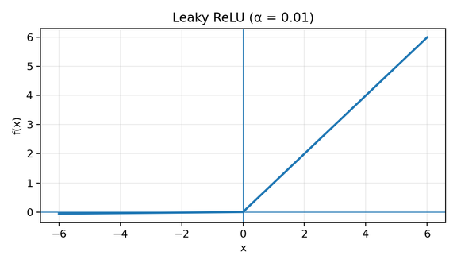

Figure: 8. Leaky ReLU graph
Advantages:
Reduces the dying ReLU problem.
Allows a small gradient for negative inputs.
Computationally simple.
Applications:
Deep neural networks
Image recognition
Classification
Feature extraction
9. ELU (Exponential Linear Unit)
ELU is a modification of ReLU that allows negative outputs for negative inputs.
Formula: f(x) = x if x > 0; α(eˣ − 1) if x ≤ 0
Range: (-α, +∞)

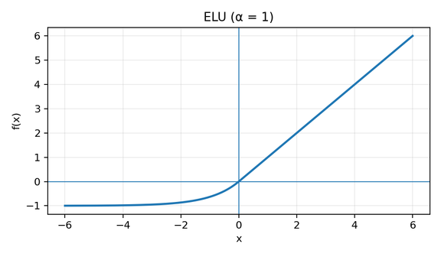

Figure: 9. ELU (Exponential Linear Unit) graph
Advantages:
Reduces the dying ReLU problem.
Produces negative outputs.
Smooth for negative input values.
Applications:
Deep neural networks
Classification
Regression
Biological data analysis
10. Softmax Activation Function
Softmax is mainly used in the output layer of multi-class classification neural networks. It converts numerical scores into probabilities whose total is equal to 1.
Formula: f(zᵢ) = eᶻⁱ / Σⱼ eᶻʲ
Range: Each output is in (0, 1); all outputs sum to 1.

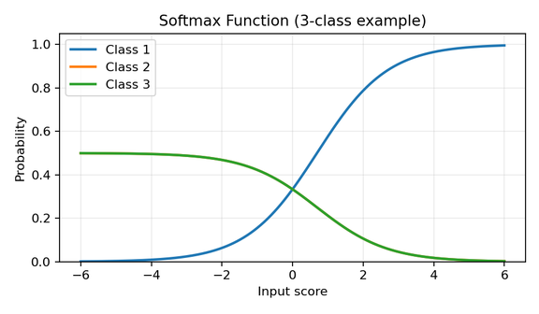

Figure: 10. Softmax Activation Function graph
Advantages:
Converts model outputs into probabilities.
The probabilities add up to 1.
Useful for multi-class classification.
Provides an interpretable probability distribution.
Applications:
Multi-class classification
Species classification
Disease classification
Classification of biological samples
11. Comparison of Activation Functions
Activation Function | Formula | Range | Major Advantage | Common Application
Binary Step | 0 if x<0, 1 if x≥0 | {0,1} | Simple | Binary decisions
Linear | f(x)=x | (-∞,+∞) | Continuous output | Regression
Sigmoid | 1/(1+e⁻ˣ) | (0,1) | Probability-like output | Binary classification
Tanh | tanh(x) | (-1,1) | Zero-centered | Sequence models
ReLU | max(0,x) | [0,+∞) | Efficient | Deep networks/CNNs
Leaky ReLU | αx if x<0; x otherwise | (-∞,+∞) | Reduces dying ReLU | Deep networks
ELU | x if x>0; α(eˣ−1) otherwise | (-α,+∞) | Smooth negative region | Deep networks
Softmax | eᶻⁱ/Σeᶻʲ | (0,1) | Probability distribution | Multi-class classification
12. Selection of Activation Function
The choice of activation function depends on the type of neural network and the problem being solved.
Binary Step: Simple binary decision systems.
Linear: Regression and continuous-value prediction.
Sigmoid: Binary classification output.
Tanh: Some hidden layers and recurrent networks.
ReLU: Common default for hidden layers in deep neural networks.
Leaky ReLU: Useful when avoiding dying ReLU is important.
ELU: Useful when smooth negative activations are desirable.
Softmax: Multi-class classification output.
In a typical neural network, different activation functions may be used in different layers. For example, a deep neural network may use ReLU in its hidden layers and Softmax in its output layer for multi-class classification.
13. Importance in Biotechnology
Activation functions are particularly important in biotechnology because neural networks are increasingly used to analyze complex biological datasets.
Genomics: DNA and RNA sequence classification
Proteomics: Protein classification and structure prediction
Drug discovery: Prediction of drug activity
Microbiology: Microorganism classification
Medical biotechnology: Disease classification
Bioimaging: Analysis of microscopic images
Bioprocessing: Prediction and optimization of biological processes
The appropriate activation function allows the neural network to learn useful patterns from these datasets and generate meaningful predictions.
14. Conclusion
Activation functions are essential components of artificial neural networks. They introduce non-linearity and determine how neurons respond to their inputs. Different activation functions have different mathematical properties, output ranges, advantages, and applications.
ReLU is widely used in hidden layers of modern deep neural networks, while Sigmoid is commonly used for binary classification and Softmax for multi-class classification. Linear activation is useful for regression, while Tanh has applications in sequence-based models.
Understanding activation functions is important for selecting and designing neural-network models for applications in biotechnology, bioinformatics, data analytics, drug discovery, genomics, and biomedical research.

